Digital Workforce

**Process Definition Document**



**Stellaris Ticket Creation Process**

Document Control

|  |  |
| --- | --- |
| **Document information** | |
| Customer | Stellaris |
| Project | Stellaris Ticket Creation Process |
| Owner | Cynthia Wilkinson |
|  | |

|  |  |  |  |  |
| --- | --- | --- | --- | --- |
| **Version** | **Date** | **Title** | **Author** | **Changes** |
| 1 | 06/18/2019 | Solution Archetect | Srinivas Encherla |  |
| 2 |  |  |  |  |
|  | Click here to enter a date. |  |  |  |

|  |  |  |  |
| --- | --- | --- | --- |
| **Document Change Reviewers/Approvers** | | | |
| **Approved Date** | **Title** | **Name** | **E-mail** |
|  |  |  |  |
|  |  |  |  |
|  |  |  |  |

Table of Contents

1. Proejct Name 3

**1.1** **Introduction** 4

**1.2** **Project Scope** 4

2. Overview of the current process 5

**2.1** **Current Process Diagram** 5

**2.2** **Metrics** 6

**2.3** **Process Details** 6

3. Appendix 11

3.1 Contact list of the SME Team 11

3.2 Contact list of the Team 11

# Project Name

## **Introduction**

Description of the process at a high level.

*Creating tickets in BMC Remedy Tool for emails in outlook. Users will request services in email (with or without attachment) in outlook, Bot has to extract these email requests and create a ticket accordingly.*

## **Project Scope**

The project scope is to capture current process and the parts to automate.

Please refer to the document below to understand the process execution stages for automation.

# Overview of the current process

## **Current Process Diagram**

A high level overview diagram of the current process.

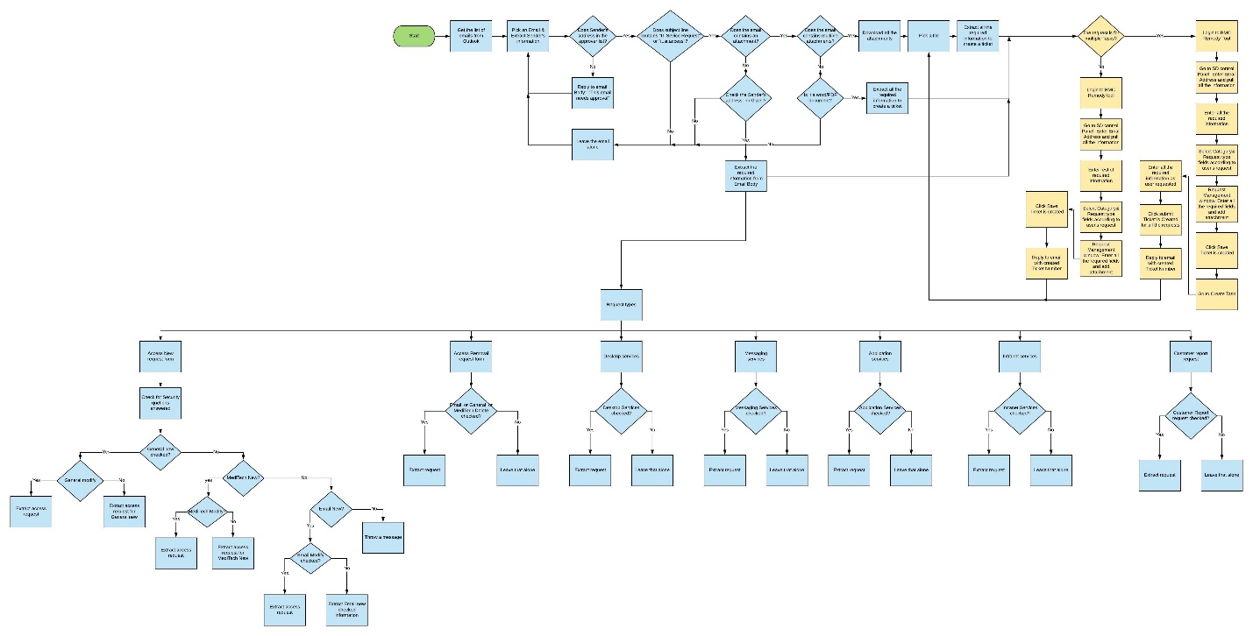

## **Metrics**

Key Metrics related to the process.

|  |  |  |
| --- | --- | --- |
| 1 | **Role(s) required for performing the process** | BMC tool – Ticketing system  Module “Tickets” – Rights “ Read &Write”  Outlook Email Service  Module “Emails” – Rights “ Read &Write” |
| 2 | **Process schedule and frequency** | *24/7* |
| 3 | **# of items processes /reference period** | *700 tickets per month* |
| 4 | **Average handling time per item** | *5-6 minutes* |
| 5 | **Peak period (s)** | Later in the morning to 8 am to 5Pm EST |
| 6 | **Transaction Volume During Peak period** | *NA* |
| 7 | **Total # of FTEs supporting this activity** | 9 FTE during day , 2 FTE at night |
| 8 | **Expected increase of volume in the next reference period** | *None* |
| 9 | **System/application Availability** | *None* |
| 10 | **Any Holidays Bot should exclude to run** | *None* |
| 11 | **Level of exception rate** | *N/A* |
| 12 | **Input data; Output** | User Emails from Outlook; Creating ticket for requests in emails |

## **Process Details**

\**Some screenshots were removed as they contained sensitive information.\**

|  |  |  |  |
| --- | --- | --- | --- |
| **Step** | **Detail** | **Comments** | |
| **1 .0** | **Open Outlook email service** |  | |
| 1.1 | Go to ‘Stellaris SeviceDesk’ account  (Emails From: DS-Service Desk Stellaris Health) |  | |
| 1.2 | Go to ‘Inbox’ |  | |
| 1.3 | Pick an email(Older to newer) |  | |
| 1.4 | Check Email Body, Subject, and Address | If Body contains   1. Approve 2. Approved 3. Please process   Or  If Subject contains   1. it.sr.access. 2. lawrence hospital   Or  If Address contains   1. nom9016@nyp.org 2. kit9017@nyp.org 3. @nyp 4. @wphospital | |
| 1.4.1 | If 1.4 is ‘True’  Check for attachments | If it contains   1. word document   and check   1. attachment name contains ‘Request’ | |
| 1.4.2 | If 1.4.1 is ‘True’  Save attachment and Email message in shared folder |  | |
| 1.4.3 | Extract all the required information from document (Please refer document in additional notes) | All the checked check boxes information   1. Personal information   Name and email   1. All Request services information 2. Access New   And  At least one Security question answered out of 2   1. Access removal 2. Desktop 3. Messaging 4. Application 5. Intranet 6. Customer report | |
| 1.4.4 | Check if user has requested for multiple service requests  (Ex: Checked both MediTech New and Desktop Services) |  | |
| **2.0** | **Go to Outlook Email**  Get the subject & Body of Email | If Subject contains  ‘Lawrence’ and Body contains ‘cwid’ | |
| 2.1 | If body in 2.0 step doesn’t contains ‘cwid’, throw Business exception |  | |
| 2.2 | Check for attachment type- word document  If there is no attachment, check for address “@northwell” | If it’s not word document, throw business exception | |
| 2.3 | (From 1.4) If Body does not contains   1. Approve 2. Approved 3. Please process   Reply to email with body ‘This email needs approval, Could you please approve?’ and move email to ‘BOTChecked’ folder |  | |
| 2.4 | From 2.2, email address contains ‘@northwell’  Check if the email in approval list, if not, send an approval email, move email to ‘BOTChecked’ folder |  | |
| 2.5 | From 2.4, if condition is ‘True’, extract all the information from the body | Extract:   1. Requested by 2. First Name 3. Last Name 4. Northwell Hospital Name 5. Description 6. Date needed 7. Customer First & Last name | |
| **3.0** | **Login to BMC Tool** |  | |
| 3.1 | Enter Email Address (From 1.4.3), hit enter, all the information will shows up, if not, enter all the extracted information (From 1.4.3)- First Name, Last Name, Email address, Phone number, Facility/Location, State, Account affected to ‘Stellaris Health Network’, and Source to ‘Email’ |  | |
| 3.2 | Enter Short Description as ‘Subject Request/ FirstName LastName’ as shown in picture |  | |
| 3.3 | If “AR system user error” window appears on the screen  Throw exception |  | |
| 3.4 | If “Selection List” window appears, select second row from the list and click ‘OK’ |  | |
| 3.5 | Click on ‘Request Management’ tab |  | |
| 3.6 | Select ‘Category’ as ‘Security’ | If Access requested in Word document is for:   1. General   or   1. Meditech or 2. Email | |
| **3.7** | **If Access request type is ‘New’**  If the user requested for all ‘general new’ and ‘meditech new’ and ‘email new’   1. For White plains- select below requested type      1. For Lawrence- select below requested type      1. For NorthWest chester – select below requested type      1. For Phelps – select below requested type |  | |
| 3.8 | Click ‘Create Request’ |  | |
| 3.9 | Click on ‘Detailed Description’ and enter email body in it and click ok. |  | |
| 4.0 | If date is correct format from email, enter in ‘Date Required’ field |  | |
| 4.1 | Click on ‘Requirements’ tab and enter ‘y’/’yes’ in answer fields for all the security questions answered from document. |  | |
| 4.2 | Click on ‘Documents’ tab and Zip file(of document) if ‘White Plains’/’Lawrence’, else saved email file and click save |  | |
| 4.3 | Get the ticket number |  | |
| 4.4 | If user is not requested for multiple services,  Reply back to the email with created Ticket# and edit the subject to: ‘Rpa’+Ticket number+ Date+ Subject |  | |
| 4.5 | Click on ‘Customer Information’ tab  And double click on ‘Request ID’ from ‘Request history-customer’ field |  | |
| 4.5.0 | If user is requested for multiple services,  Click on create task, |  | |
| 4.5.1 | Click on Task details, click on assignment group and select ‘Stellaris SecAdmin’ |  | |
| 4.5.2 | Click ‘Notification’ tab, enter ‘completed’ in Task Name field and select ‘Email’ for assignee notification and check ‘24X7’ and click submit |  | |
| 4.5.3 | Click close |  | |
| 4.6 | Get back to outlook, and process another email  Repeat all the steps from 1.3 to 3.6 |  | |
| 4.7 | If the user requested for only ‘general new’ and ‘meditech new’  Select below requested type    And Repeat all the steps from 3.8 to 4.4 |  |
| 4.8 | If user requested for only ‘General’  And if checked for ‘White plains’ and ‘email new’  Select    If not,  Select    And repeat all the steps from 3.8 to 4.4 |  |
| 4.9 | If user requested for only ‘meditech new’  And if checked for ‘White plains’ and ‘email new’  Select    If not,  Select    And repeat all the steps from 3.8 to 4.4 |  |
| 5.0 | If user requested for only ‘email new’  And if checked for ‘White plains’  Select    And repeat all the steps from 3.8 to 4.4 |  |
| **5.1** | **If Access requested for ‘Modify’**  If user requested only for ‘General modify’ and ‘meditech modify’  Select    And repeat all the steps from 3.8 to 4.4 |  |
| 5.2 | If user requested for multiple services,  Repeat the steps from 4.5 to 4.5.3 |  |
| 5.3 | If user requested only for ‘General modify’,  Select    And repeat all the steps from 3.8 to 4.4 |  |
| 5.4 | If user requested for multiple services,  Repeat the steps from 4.5 to 4.5.3 |  |
| 5.5 | If user requested only for ‘meditech modify’,  Select    And repeat all the steps from 3.8 to 4.4 |  |
| 5.6 | If user requested for multiple services,  Repeat the steps from 4.5 to 4.5.3 |  |
| **5.7** | **Access Request type is ‘Delete’** |  |
| 5.8 | If user checked for  ‘white plains’, Select    ‘Lawrence’, select    ‘Phelps’, select    ‘NWH’, select    And repeat all the steps from 3.8 to 4.4 |  |
| 5.9 | If user requested for multiple services,  Repeat the steps from 4.5 to 4.5.3 |  |
| **6.0** | **Access Request type is ‘Desktop Services’** |  |
| 6.1 | If requested for ‘Desktop white’  Select category as ‘Infrastructure’ and request type ‘IMAC-Software(LHC)’  Repeat the steps from 3.9 to 4.4 |  |
| 6.2 | If user requested for multiple services,  Repeat the steps from 4.5 to 4.5.3, except in 4.5.1 step, select as shown below |  |
| **6.3** | **Access request type is ‘Messaging’** |  |
| 6.4 | If requested for ‘messaging white’  Select category as ‘Messaging’ and request type ‘Mail Request - Ads’  Repeat the steps from 3.9 to 4.4 |  |
| 6.5 | If user requested for multiple services,  Repeat the steps from 4.5 to 4.5.3, except in 4.5.1 step, select as shown below |  |
| **6.6** | **Access Request type is ‘Intranet services’** |  |
| 6.7 | If requested for ‘intranet lawrence’ or ‘intranet nwh’  Select category as ‘GIS Common’ and request type ‘Intranet Service Request’  Repeat the steps from 3.9 to 4.4 |  |
| 6.8 | If user requested for multiple services,  Repeat the steps from 4.5 to 4.5.3, except in 4.5.1 step, select as shown below |  |
| **6.9** | **Access Request type is ‘Application Services’** |  |
| 7.0 | If requested for ‘Application’  Select category as ‘Applications’ and request type ‘MT MIS/Technical’  Repeat the steps from 3.9 to 4.4 |  |
| 7.1 | If user requested for multiple services,  Repeat the steps from 4.5 to 4.5.3, except in 4.5.1 step, select as shown below |  |
| **7.2** | **Access Request type is ‘Customer Report’** |  |
| 7.3 | If requested for ‘Application’  Select category as ‘Applications’ and  If request type is for Report new, select ‘NPR – New Report (Meditech)’  If request type is for Report modify, select ‘NPR – Modify Report (Meditech)’  Repeat the steps from 3.9 to 4.4 |  |
| 7.4 | If user requested for multiple services,  Repeat the steps from 4.5 to 4.5.3, except in 4.5.1 step, select as shown below |  |
| **7.5** | **Access request type is ‘3M Access’** |  |
| 7.6 | If any of service requests checked and ‘meditech new’ is checked  Repeat the steps from 4.5 to 4.5.3, except in 4.5.1 step, select as ‘Stellaris-meditech-Admin’ and 4.5.2 step Task Name is ‘3M Access’ |  |
| **7.7** | **Move the saved email to shared folder** |  |

# Appendix

## Contact list of the SME Team

|  |  |  |  |
| --- | --- | --- | --- |
| **NAME** | **ROLE** | **EMAIL** | **PHONE NUMBER** |
| Cynthia Wilkinson | SME | [Cynthia.Wilkinson@nttdata.com](mailto:Cynthia.Wilkinson@nttdata.com) |  |
|  |  |  |  |

## Contact list of the Team

|  |  |  |  |
| --- | --- | --- | --- |
| **NAME** | **ROLE** | **EMAIL** | **PHONE NUMBER** |
| Srinivas Encherla | Solution Architect | [Srinivas.encherla@nttdata.com](mailto:Srinivas.encherla@nttdata.com) |  |
| Venkatesh Sigamsitty | Sr. RPA Developer | [Venkatesh@novatiosolutions.com](mailto:Venkatesh@novatiosolutions.com) |  |
| Kamal K | Business Analyst | [Kamal.k@nttdata.com](mailto:Kamal.k@nttdata.com) |  |

**Additional Notes**

Reference documents: